What is slope?
What is slope? If you have ever walked up or down a hill, then you have already experienced a real life example of slope
As you go up hill, you may feel like you are spending lots of energy to get yourself to move.
The steeper the hill, the harder it is for you to keep yourself moving
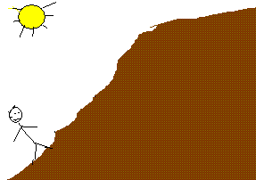
Keeping this fact in mind, by definition, the slope is the measure of the steepness of a line.
In real life, we see slope in any direction. However, in math, slope is defined from left to right.
I repeat we always measure slope going from left to right. This is very important!
There are three types of slope you can encounter. A slope can be positive, negative, or equal to zero. When the slope is equal to zero, we say that there is no slope
A positive slope:
If you go from left to right and you go up, it it a positive slope
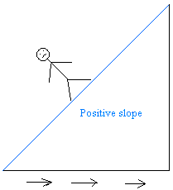
A negative slope:
If you go from left to right and you go down, it it a negative slope
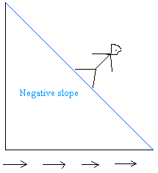
A zero slope:
If you go from left to right and you don't go up or down, it is a zero slope
