Name:__________________________________________________Date:__________Per:____
Graphing Lines Using x and y intercepts

1. The perimeter of a rectangular park is 72 feet. Let x be the park’s width (in feet) and y be its length (in feet).
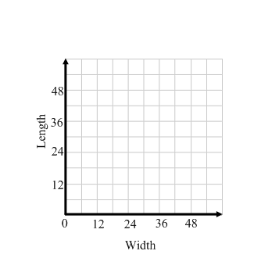
a) Write an equation to represent the perimeter.

b) Graph the equation.

c) What do the intercepts mean in this situation?
Do they make sense as a possible solution to the problem?

d) Give two possibilities for the length and width of the park.

e) Identify the domain and range of the function.

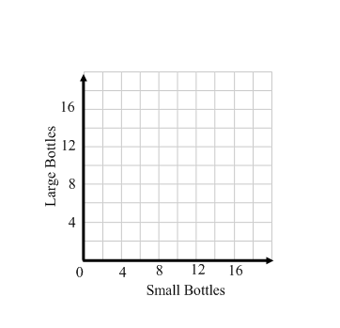
2. In one state, small bottles have a refund value of $0.04 each, large bottles have a refund value of $0.08 each. Your friend returns both small and large bottles and receives $0.56. This situation is given by 4x + 8y = 56 where x is the number of small bottles and y is the number of large bottles.
a) Graph the equation.
b) Give three possibilities for the number of each size of
bottle your friend could have returned.

c) Identify the domain and range of the function.

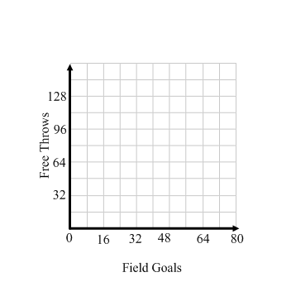
3. Before 1979, there was no 3-point shot in professional basketball; players could score only 2-point field goals and 1-point free throws. In a game before 1979, a team scored a total of 128 points.
a) Write an equation to represent the situation.

b) Graph the equation.

c) What do the intercepts mean in this situation?

d) What are three possible numbers of field goals and
free throws the team could have scored?

e) Use your graph to determine if the team made 24 free throws
how many field goals were made.

f) Identify the domain and range of the function.

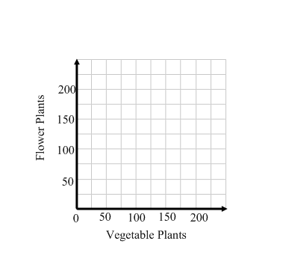
4. A family has a plot in a community garden. The family is going to plant vegetables, flowers or both. The diagram shows the area used by one vegetable plant and the area of the entire plot. The area f (in square feet) of the plot left for flowers is given by f = 180 – 1.5v where v is the number of vegetable plants the family plants.
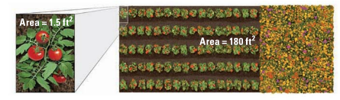
a) Find the intercepts of the graph of the function and
state what the intercepts represent.

b) Graph the function.
c) Identify its domain and range.
d) The family decides to plant 80 vegetable plants.
How many square feet are left to plant flowers?

