Name ____________________________________ Date _____________________________________
We have been working on making tables, writing rules, graphing, and algebraic phrases. One of these is given to you below. Fill in the other missing sections.
1)
Verbal Phrase
Rule

Table
Graph

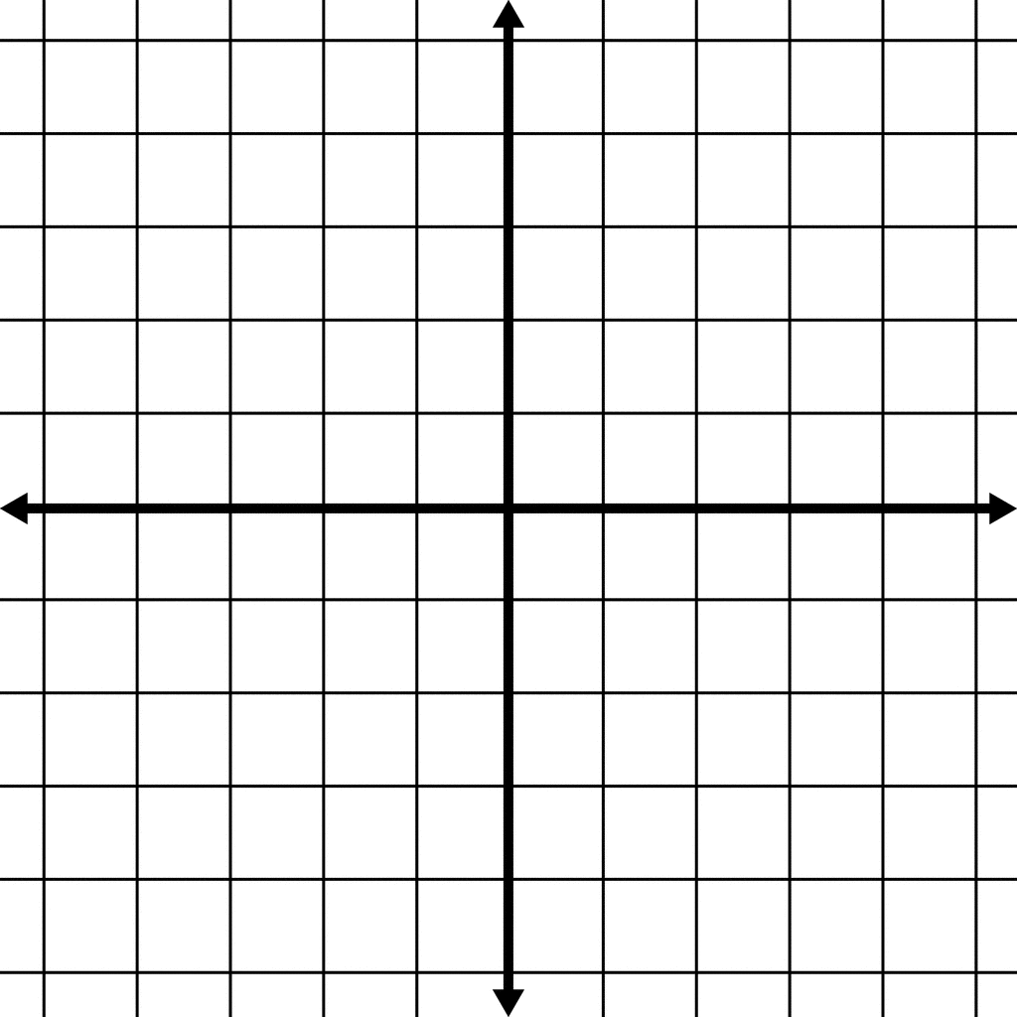

Input | -1 | 0 | 1 | 2 | 3
Output | -2 | 1 | 4 | 7 | 10

Verbal Phrase
Rule
Graph
2)

Five less than twice a number

Table

Input
Output

